

Log4j Script User Guide

Version 0.1
Dec/21/2021

Author (s) Name: Freddy Chen

Overview
Apache Log4j2 versions 2.0-alpha1 through 2.16.0 did not protect from uncontrolled recursion from self-referential lookups. When the logging configuration uses a non-default Pattern Layout with a Context Lookup (for example, $${ctx:loginId}), attackers with control over Thread Context Map (MDC) input data can craft malicious input data that contains a recursive lookup, resulting in a StackOverflowError that will terminate the process. This is also known as a DOS (Denial of Service) attack
Ruckus Unleashed Multi-Site Manager (a.k.a UMM) has fixed above log4j vulnerability in 2.6 Release.
However, for the customer who is not going to upgrade their UMM to 2.6, Ruckus release a Linux script (log4jJndiFix.sh) and customer can fix the log4j vulnerability by running the script on their UMM server.
The scope of this document is to describe the usage and limitation of this Linux script .

Support UMM version
The script support following UMM version:
- UMM 2.0
- UMM 2.1
- UMM 2.2
- UMM 2.3
- UMM 2.4
- UMM 2.5
- FlexMaster 9.13.1

Note: UMM 2.6 or above don’t need the script since the vulnerability has been fixed already.

Step to apply the Script
Following is the step to apply the script:
- Upload the script to the UMM server
- SSH to the UMM server and login as ROOT user
- Go to the folder which the script has been uploaded
- Execute following Linux command(mark in red) to apply the script
[root@localhost ~]# pwd
/root
[root@localhost ~]# chmod +x log4jJndiFix.sh
[root@localhost ~]# ./log4jJndiFix.sh
Staring to remove JNDI lookup from /opt/UMM/3rdparty/elasticsearch/elasticsearch-5.6.14/lib/log4j-core-2.11.1.jar ...
Remove log4j JNDI lookup from /opt/UMM/3rdparty/elasticsearch/elasticsearch-5.6.14/lib/log4j-core-2.11.1.jar done ...
Staring to remove JNDI lookup from /opt/UMM/3rdparty/tomcat/apache-tomcat-7.0.91/webapps/intune/WEB-INF/lib/log4j-core-2.6.2.jar ...
Remove log4j JNDI lookup from /opt/UMM/3rdparty/tomcat/apache-tomcat-7.0.91/webapps/intune/WEB-INF/lib/log4j-core-2.6.2.jar done ...
Staring to remove JNDI lookup from /opt/UMM/apps/umm-event/lib/log4j-core-2.10.0.jar ...
Remove log4j JNDI lookup from /opt/UMM/apps/umm-event/lib/log4j-core-2.10.0.jar done ...
Staring to remove JNDI lookup from /opt/UMM/apps/umm-agent/lib/log4j-core-2.10.0.jar ...
Remove log4j JNDI lookup from /opt/UMM/apps/umm-agent/lib/log4j-core-2.10.0.jar done ...
Restarting UMM...
- UMM will restart automatically once the vulnerability has been fixed
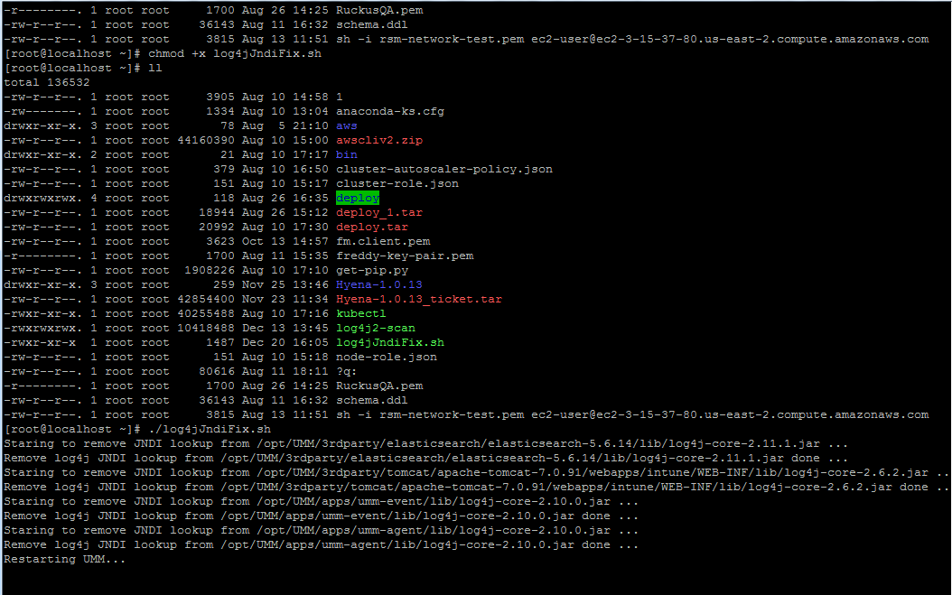

Known Limitations:
- The script is depend on ZIP, please make sure you have install ZIP to your UMM server, otherwise, the script will fail with following error:
[root@localhost ~]# ./log4jJndiFix.sh
zip not installed. Aborting
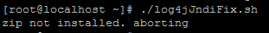
- To install ZIP, please refer to following example:
[root@localhost ~]# yum install zip -y


