Android 11 Workaround for Web Browser Trust certs
- Use existing workflow, and add a split to filter by Android OS:
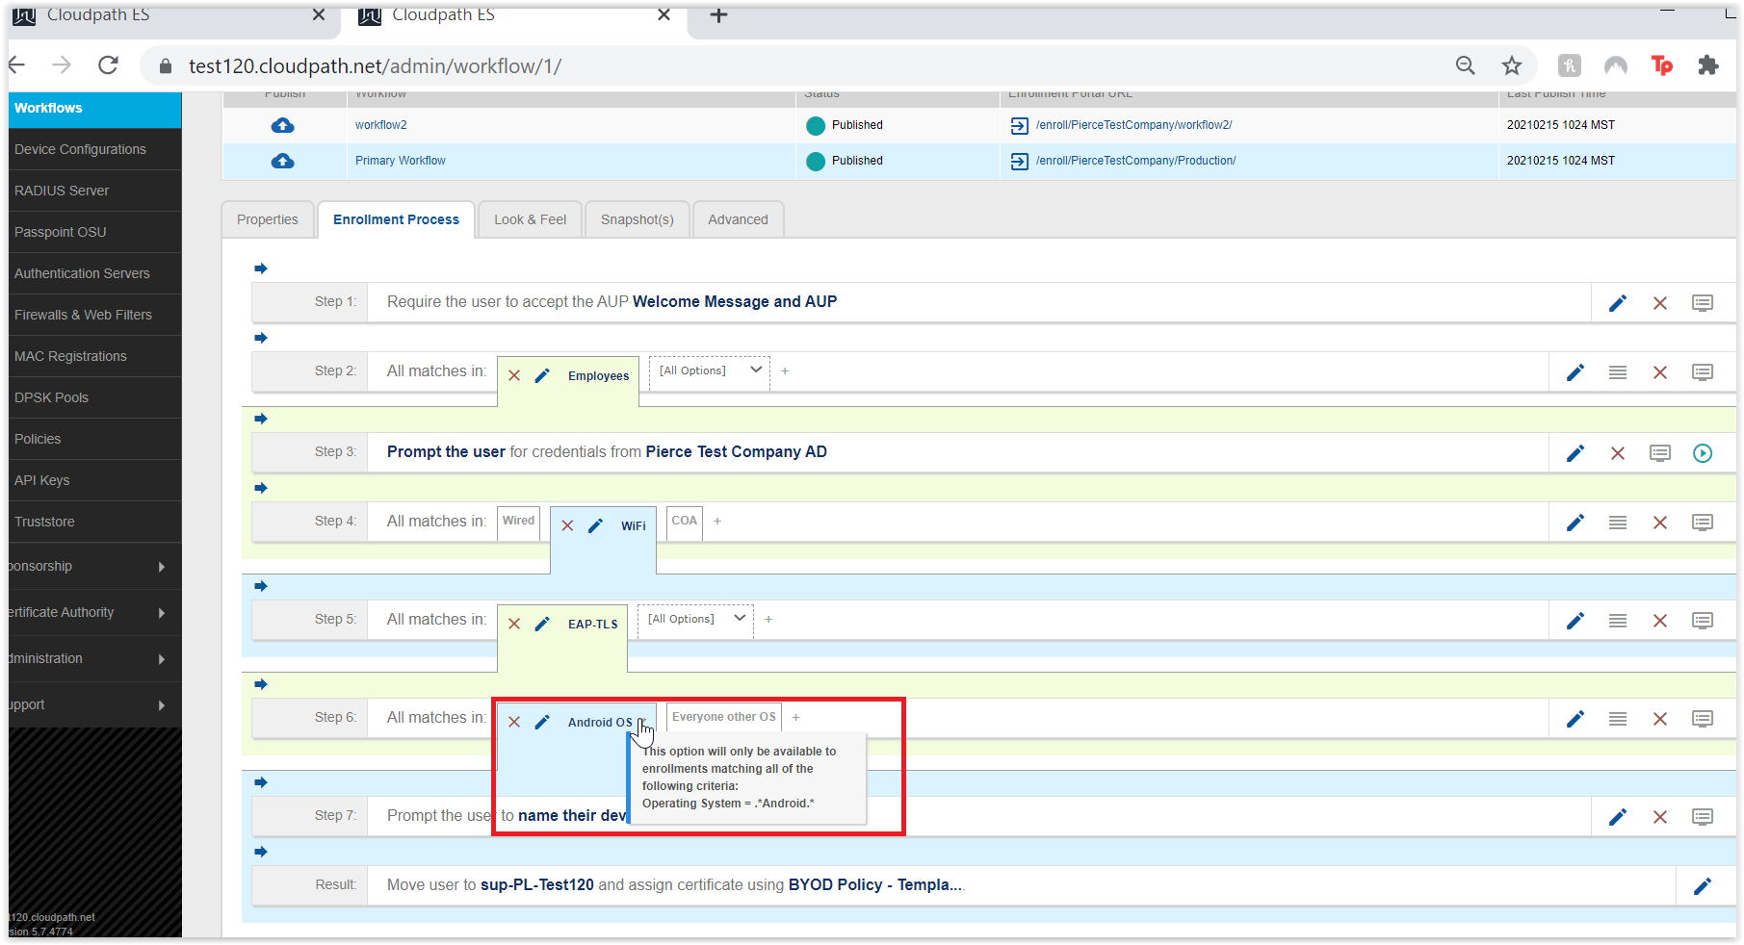
2. We would want to create a duplicate device configuration to what they are already using, however the differences highlighted in the next step will be specific to Android OS. i.e. sup-PL-Test 120 in my example
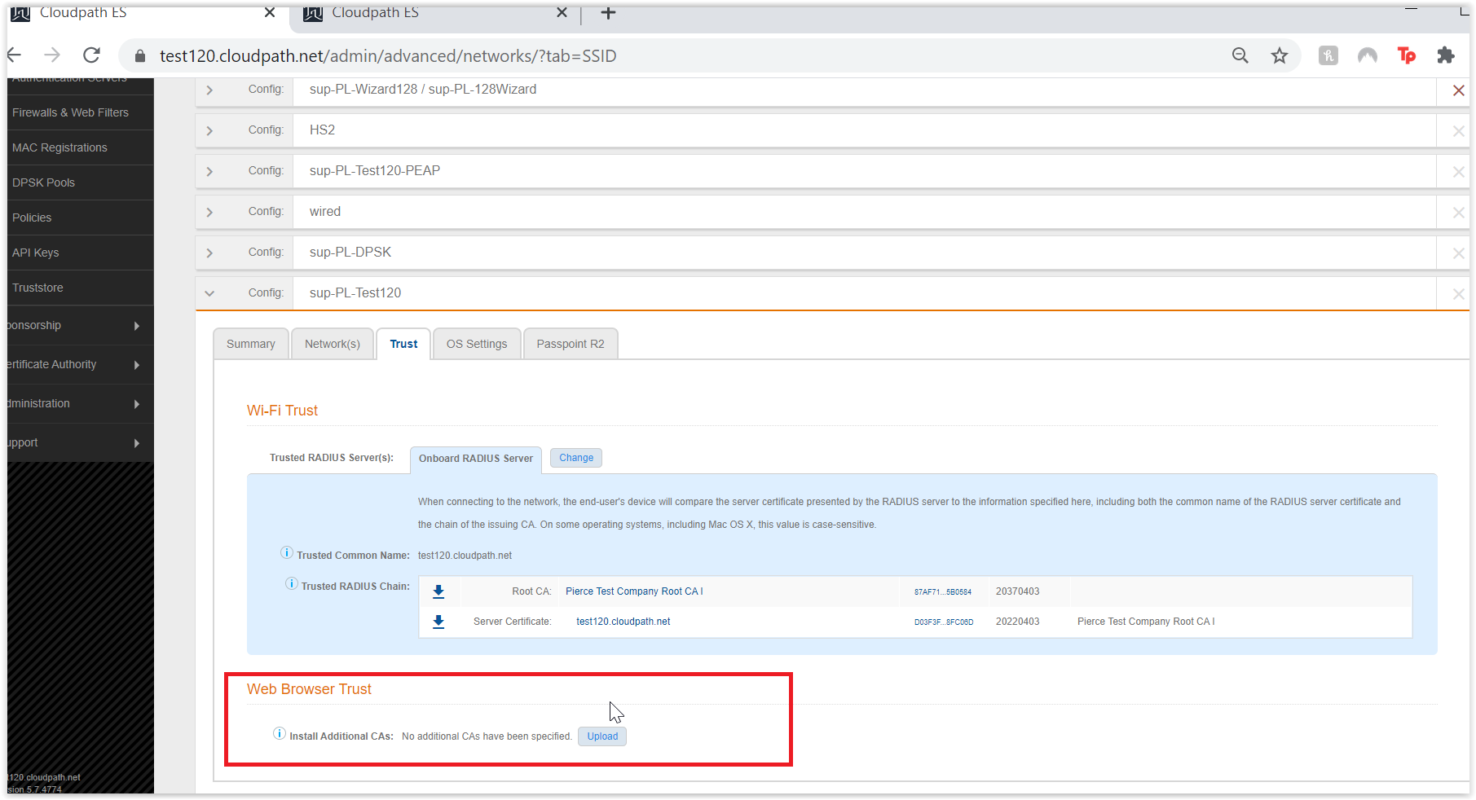Remove the Web Browser Trust cert from duplicate dev config for Android, we will add this CA on our secondary workflow device configuration below.
- Add a post-transition URL to the device configuration we created specific for Android OS. We can also disable all other support besides Android OS for this device configuration.
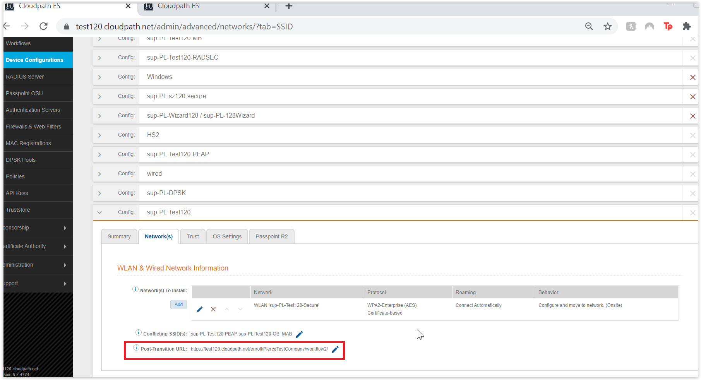

- Add a secondary workflow to the Post-Transition URL. We want this to be a blank workflow that were going to add a Display Message and a Device Configuration to.
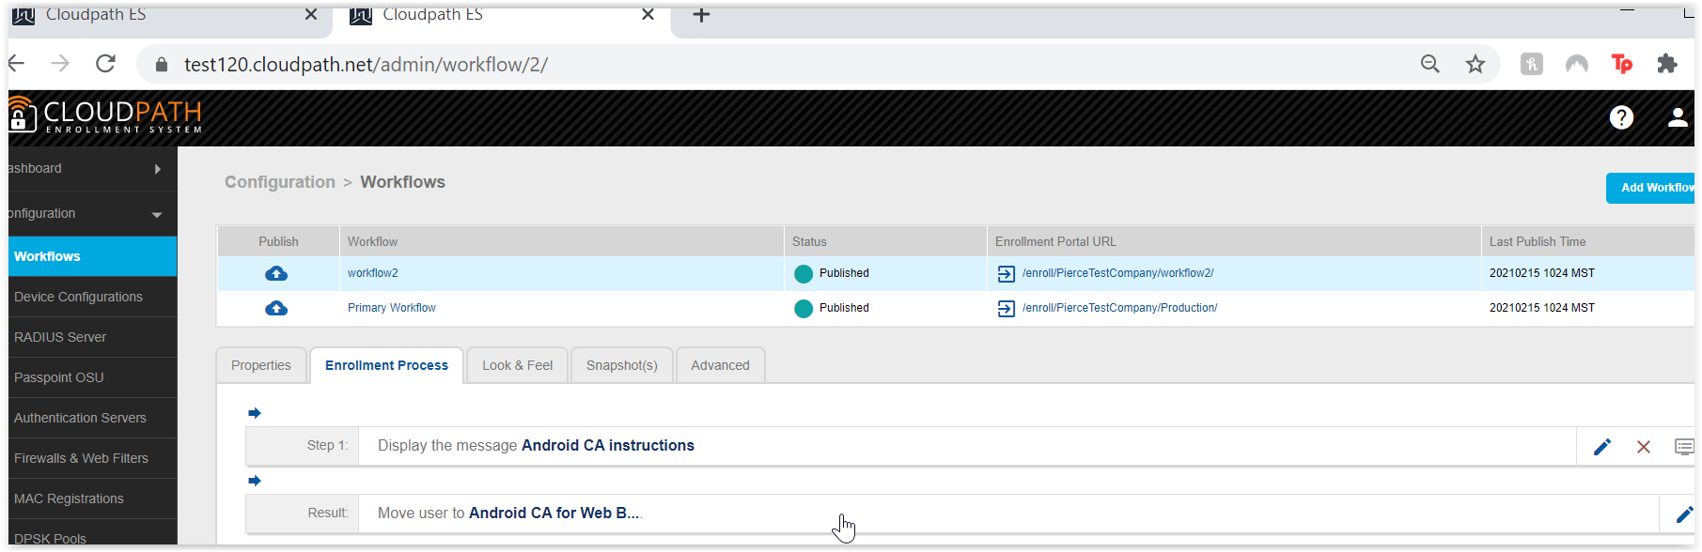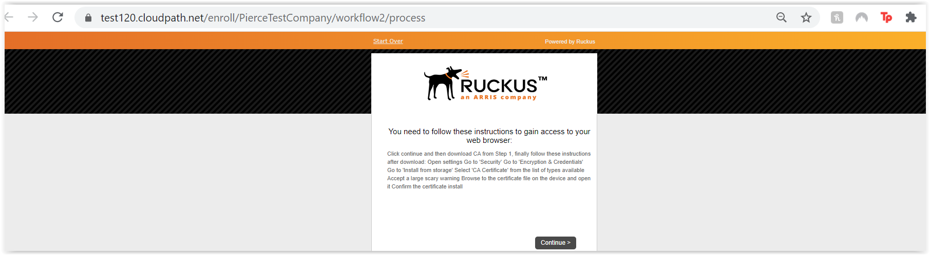
- Device Config for secondary workflow (labeled Android CA for Web Browsers in my example):
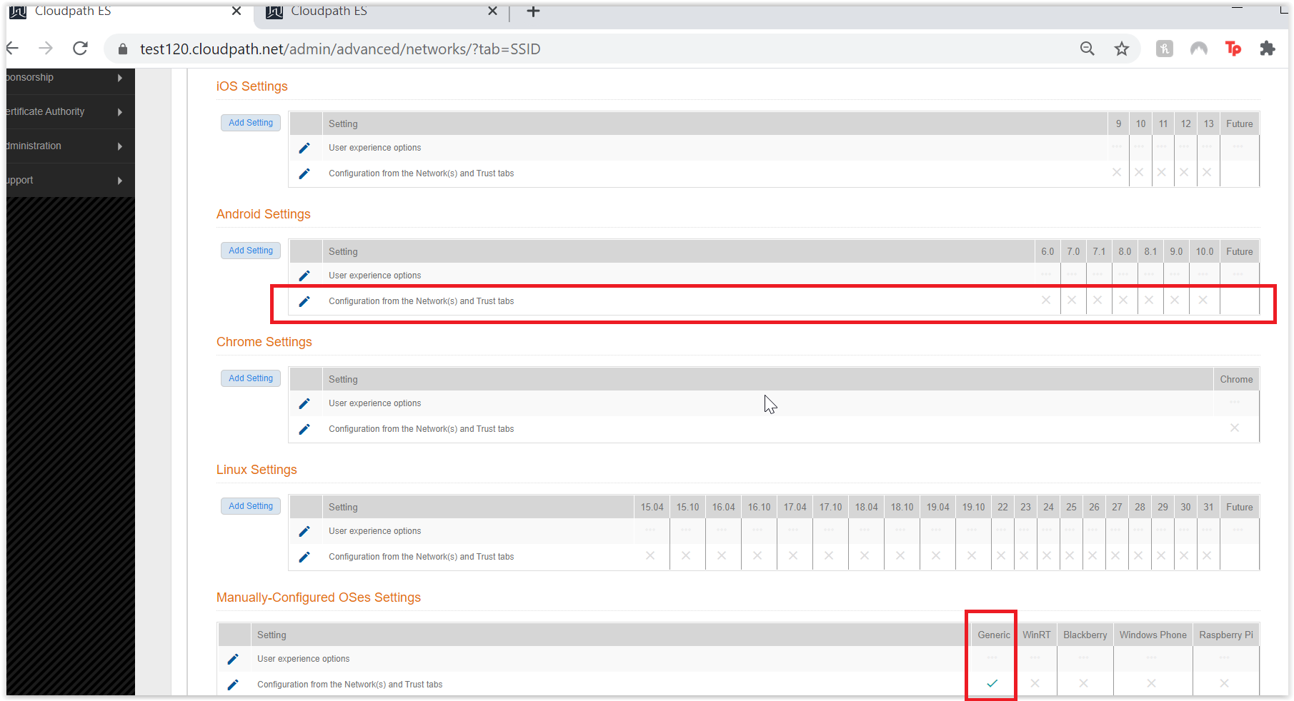
We don’t want to support any OSes except Generic here.
Disable all Android OS support along with all the OSes except the “Generic” option (this should be the only green check on the OS settings page for our “Android CA for Web Browsers” device configuration.

- We want to delete any “Network(s) To Install”, were just installing the CA for web browsers in this Device Configuration, not any networks or issuing CAs for 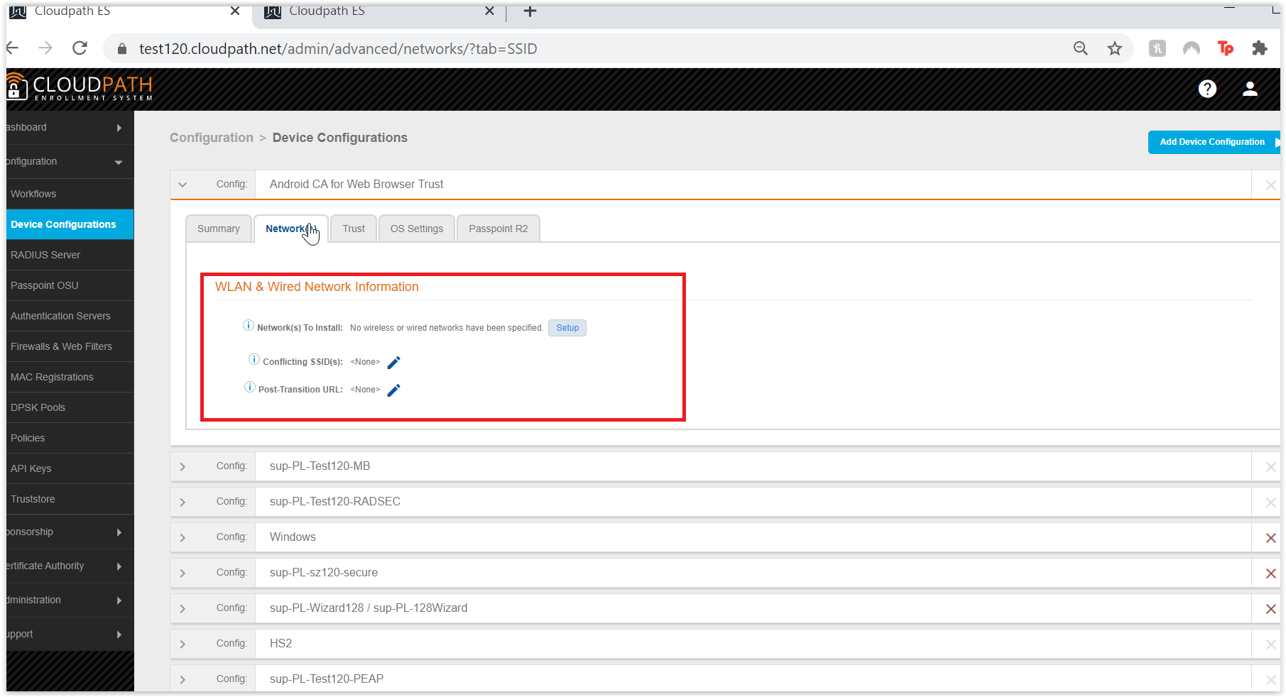Then in the Trust tab, we will have our Root CA for Web Browsers Trust.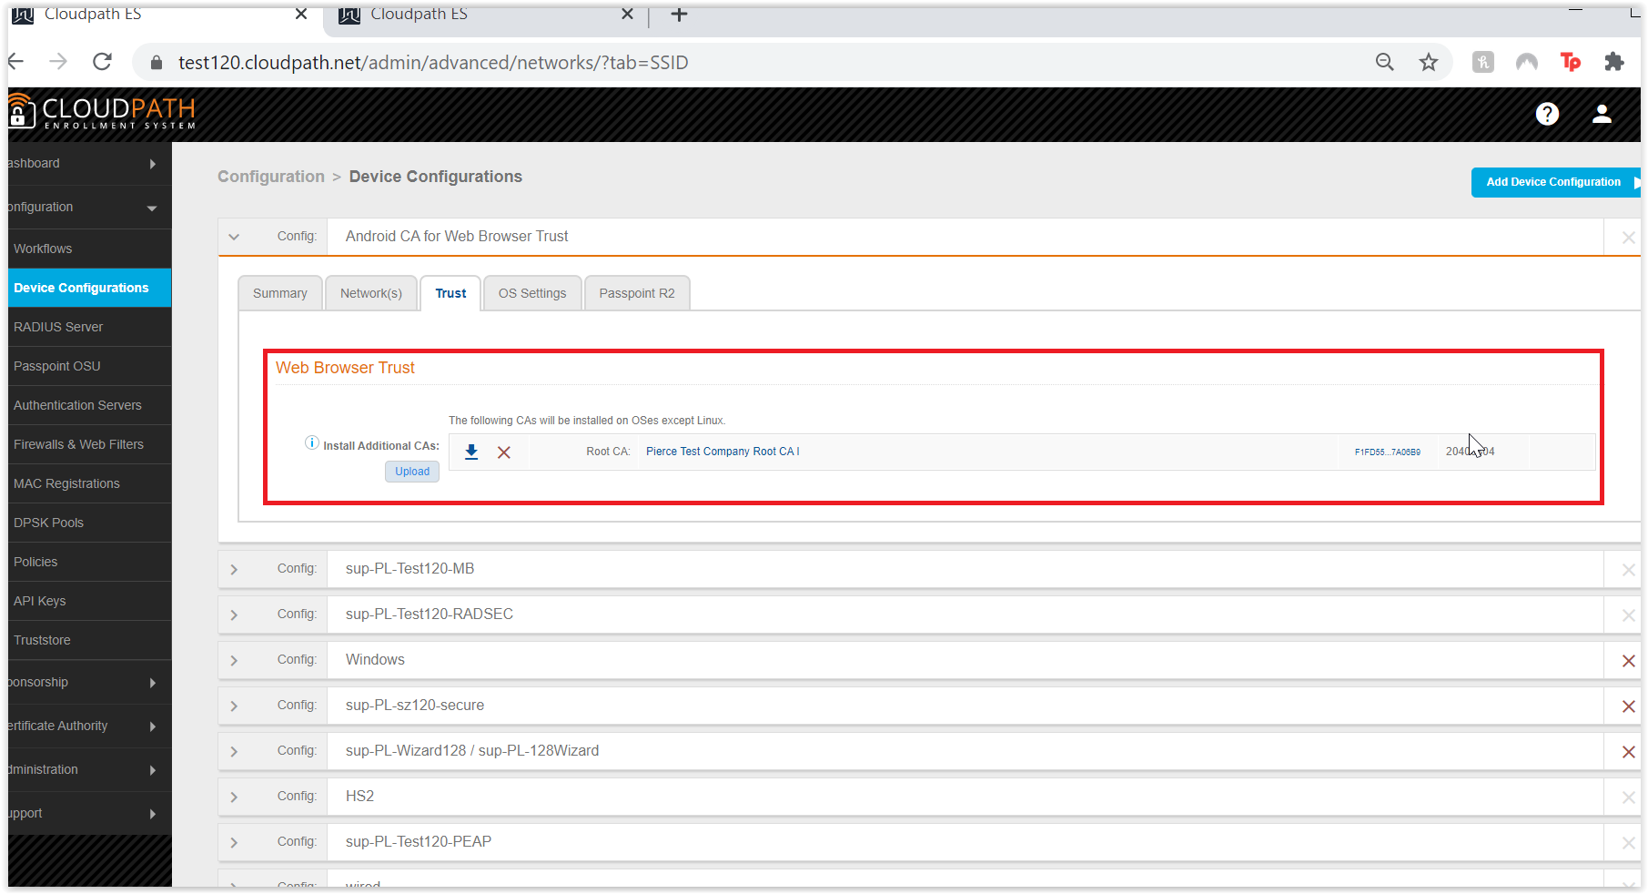

*Note, for Display Message, instructions for the CA install may differ based on Manufacturer:
Samsung:
Open settings
Go to 'Biometric and Security'
Go to 'Other Security Settings'
Go to 'Install from storage'
Select 'CA Certificate' from the list of types available
Accept a large scary warning
Browse to the certificate file on the device and open it
Confirm the certificate install
Google (Pixel):
Open settings
Go to ‘Security'
Go to ‘Encryption and Credentials’
Go to 'Install from storage'
Select 'CA Certificate' from the list of types available
Accept a large scary warning
Browse to the certificate file on the device and open it
Confirm the certificate install

