What is client fingerprinting?
Client fingerprinting is a feature effective from 9.4 firmware, it’s a technique used by ZoneDirector which attempts to identify client devices by their Operating System, device type and Host Name, if available. This makes identifying client devices easier in the Dashboard, Client Monitor and Client Details screens as shown below.
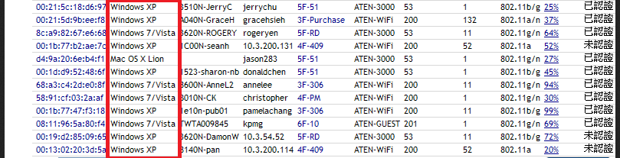

How clients fingerprinting happens?
The zone director captures the clients OS when client sends a DHCP request through the access points. The client finger printing can be enabled by clicking it in the advanced WLAN option.
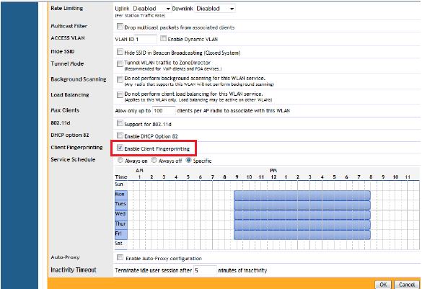
How is the OS information captured?
The ZD records the OS information from the client by capturing the DHCP request packet, the OS information is found in the DHCP option 60, a closer look into the DHCP packet reveals the following,
Packet capture of DHCP request packet,
The client used in this capture is windows7


