Filename: Standalone-AP-Upgrade.docx

Topic: What is the path to upgrade a Standalone AP from early code?

APs can upgrade/downgrade between any version, only ZDs have to follow an

upgrade path due to memory structure or internal data architecture changes.

Newer AP standalone code, under Maintenance::Upgrade page, now has a

“Local” method, in addition to FTP, TFTP which allows you to browse to the

file on your PC/laptop.

We are now providing all standalone AP firmware on our Support site. If

you have an older version of firmware that doesn’t have the Local upgrade

method option, you can make an image control file, if you know how they’re

constructed.

What is their construction you ask?  As follows…

C:\Users\michael.brado>cd c:\tftp-root\code

c:\TFTP-Root\Code>**dir *7982*.\***

Volume in drive C is OS

Volume Serial Number is E290-F83B

Directory of c:\TFTP-Root\Code

04/19/2012  07:35 PM         6,762,496 7982_9.4.0.0.103.Bl7

05/21/2012  03:44 PM         6,766,592 7982_9.4.0.0.109.Bl7

05/28/2012  01:54 AM         **6,766,592** 7982_9.4.0.0.110.Bl7

10/18/2012  11:36 PM         6,778,880 7982_9.4.2.0.29.bl7

10/23/2012  08:23 PM         7,688,192 7982_9.5.0.0.124.Bl7

11/28/2012  10:49 PM         7,753,728 ZF7982_9.6.0.0.19.Bl7

05/30/2012  02:37 PM                58 **zf7982_940_cntrl.rcks**

               7 File(s)     42,516,538 bytes

               0 Dir(s)  67,645,575,168 bytes free

c:\TFTP-Root\Code>

c:\TFTP-Root\Code>**more zf7982_940_cntrl.rcks**

**[rcks_fw.main]**

**0.0.0.0**

**7982_9.4.0.0.110.Bl7**

**6766592**

c:\TFTP-Root\Code>

    I’ve attached an example of ‘zf7980_940_cntrl.rcks’ which is

printed out above.  The image control file specifies the **Filename**

of the AP firmware, and its **Byte Count** information.  We use the

middle digits to match the version and maintenance release, so

‘_940_’ refers to version 9.4.0.x.x, and ‘_943_’ would be used with

a 9.4.3.0.12 image, if you follow the pattern (naming convention).

   With a firmware image and matching image control file in a directory

of your choosing (ie. c:\tftp-root\code), you can use your favorite TFTP

application (ie. TFTPd32), pointed to this code/image control file directory,

with the TFTP option under Maintenance::Upgrade.

<http://tftpd32.jounin.net/tftpd32_download.html>

Enter your PC’s IP address for the Firmware Server, with ‘zf7982_940_cntrl.rcks’

image control file, to upgrade manually.

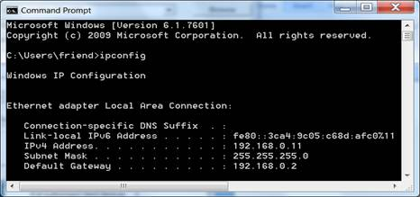

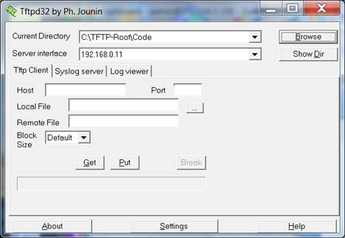

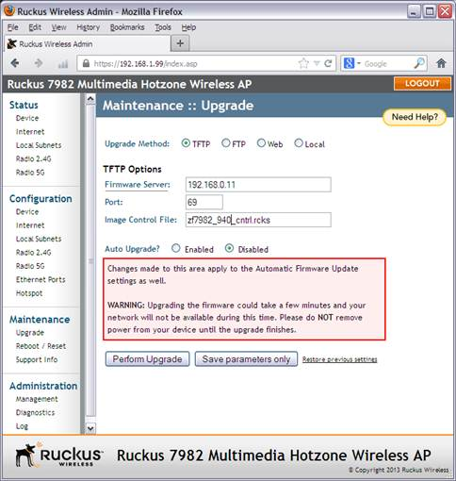

Follow the upgrade, with a reboot, from Maintenance::Reboot/Reset page, to

complete the manual upgrade procedure.