Training Document: LENNAR – RMA Creation Process

Table of Contents
Training Document: LENNAR – RMA Creation Process 1
1. Overview 2
2. Initial Troubleshooting & Case Validation 2
3. Process Flow 3
4. Contact Verification in SFDC 4
5. How to Identify the Account a Contact Is Mapped To 4
6. Customer Registration on Support Portal Article Number# 000002021 4
7. Steps for RMA Sub case creation 5
8. Queue Assignment 8

Overview
The RMA (Return Material Authorization) process for Lennar customers begins when a customer submits a request via the community form. The workflow ensures accurate contact mapping, appropriate case creation, and streamlined coordination for returns and replacements.

Initial Troubleshooting & Case Validation
- Determine if RMA is necessary or if the case remains a community case.
- Verify customer contact in Salesforce (SFDC) using their email.
- If contact is mapped to UNKNOWN Support, create an RMA sub-case under generic parent cases.
- If contact exists but is not mapped to UNKNOWN, escalate to LAT team.
- If contact doesn’t exist, guide customer to register on the support portal.

Process Flow

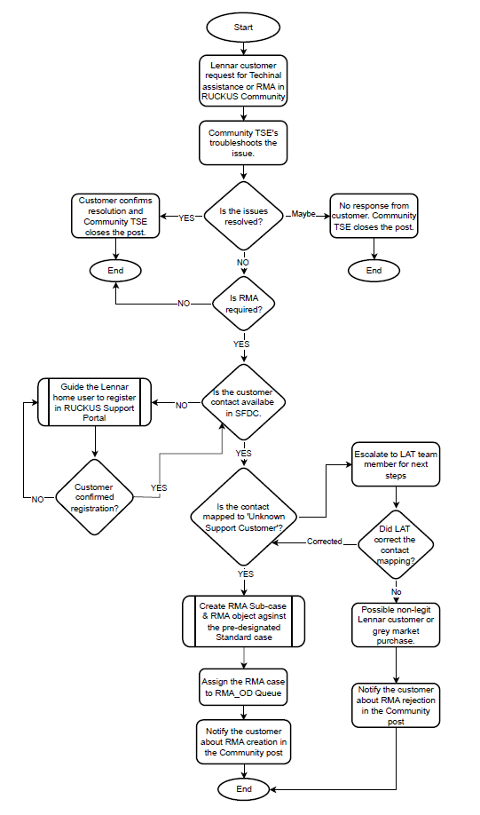

Contact Verification in SFDC
- Use Global Search Bar to query contact by email
- Check if contact is linked to correct Account
- If mapped to UNKNOWN, take corrective action

How to Identify the Account a Contact Is Mapped To
- Search/Open the Contact record in SFDC.
- Check the Account Name field — this shows the account the contact is linked to.
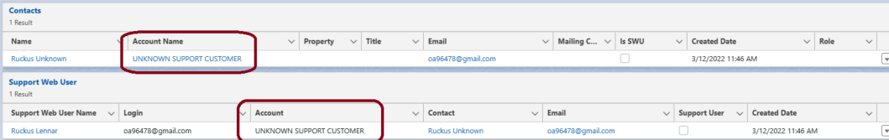
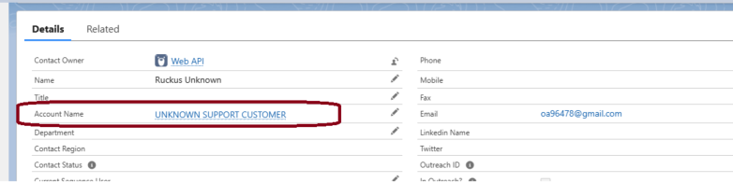

Customer Registration on Support Portal Article Number# 000002021
- Visit: https://support.ruckuswireless.com
- Click Login → Join Now
- Fill out the form, accept terms, and click Register
- Confirm email via link received
- Log in as a Guest User

Related RMA-sub case creation
Search Parent caseUsing quick links go to related cases click new
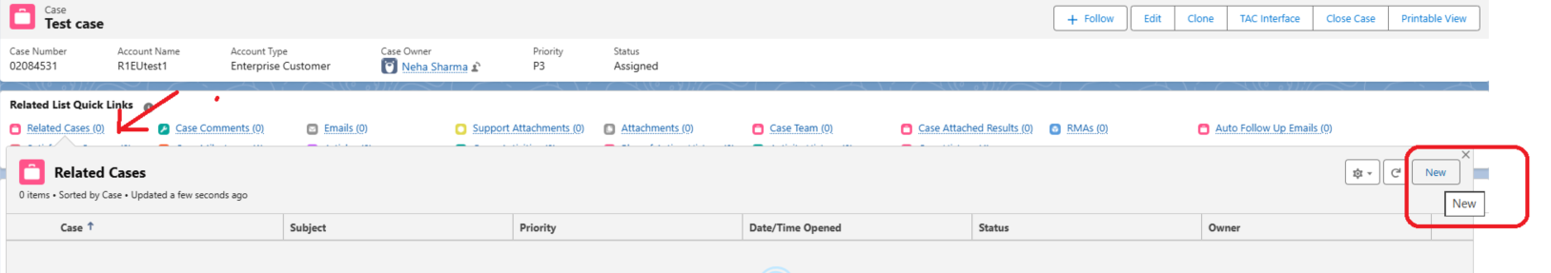
(Or) Navigate to Related tab àRelated cases
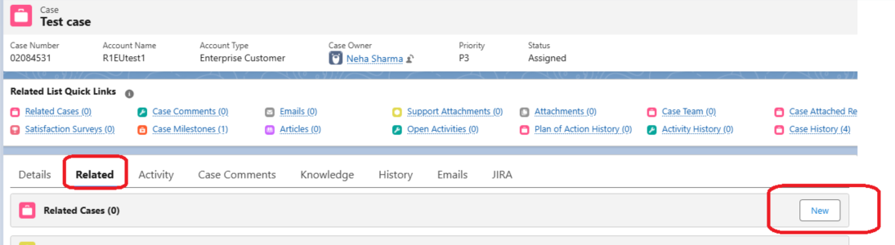

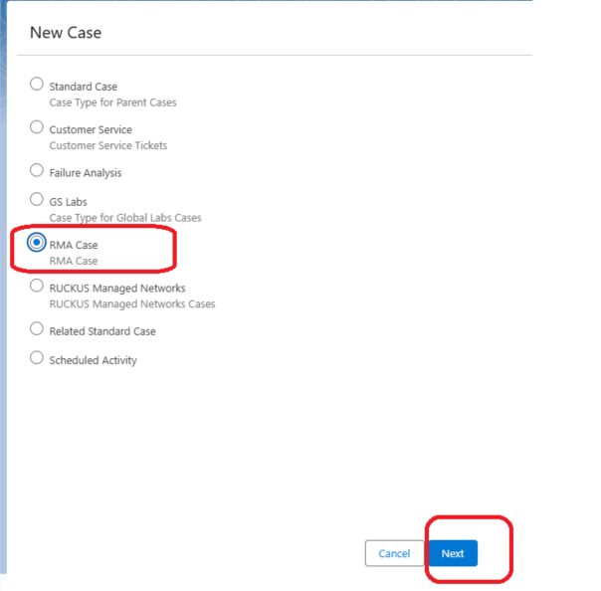
- After selecting the RMA case option, fill in the following mandatory fields: Contact Name, RMA Reason, Return Reason, Problem Type, Subject & Description.
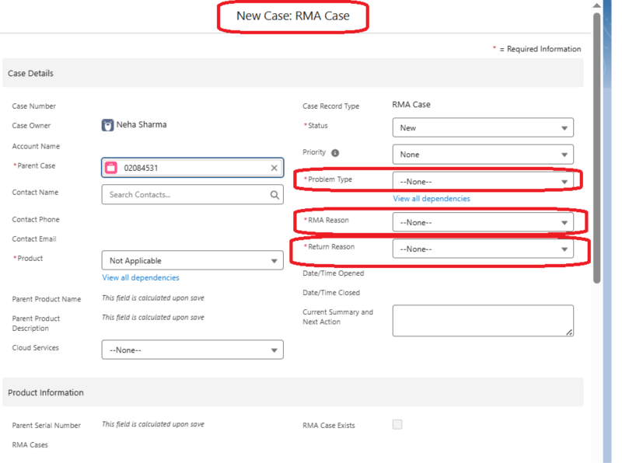
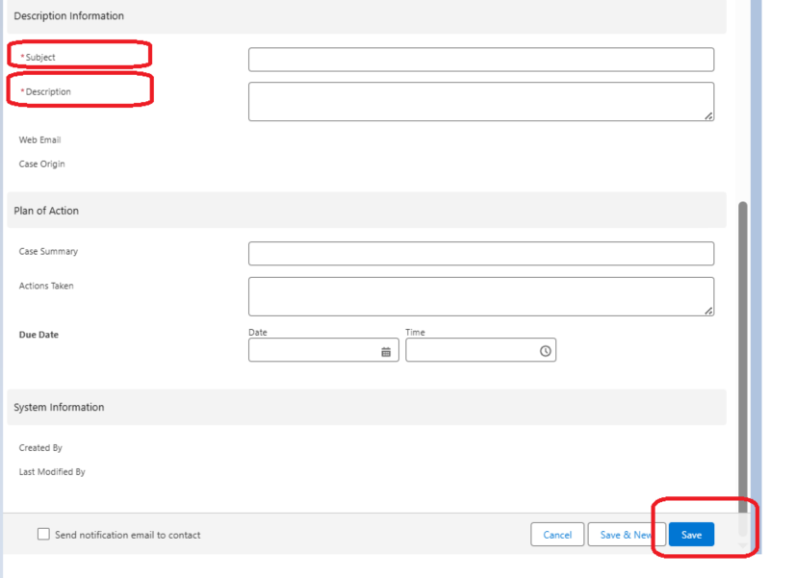
- Under the RMA case, select New RMA and provide the following shipping and product details: Serial Number, RMA Type, Company, Street, City, State/Province, Zip/Postal Code, Country, Attention, Attention Email, Attention Phone.
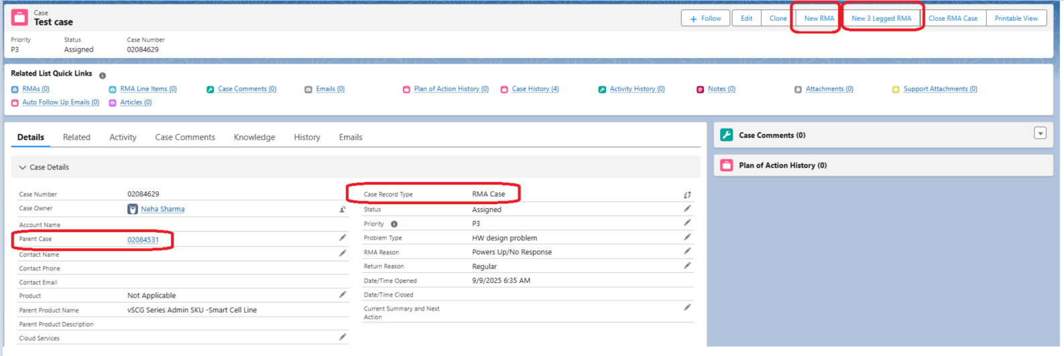
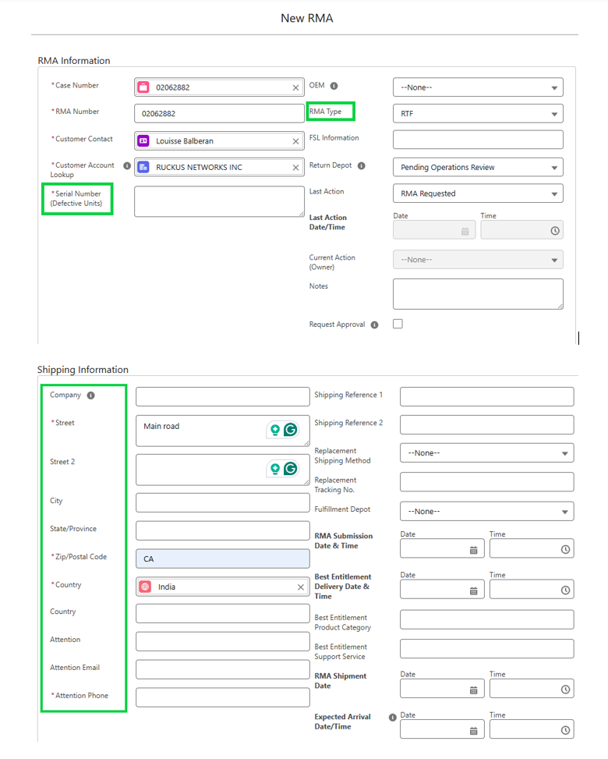
- After saving the RMA entry, navigate to the RMAs section and update the following: Failure Analysis Requested and DOA.
- Once all details are completed, submit the RMA case and assign it to the RMA-OD Queue for processing.
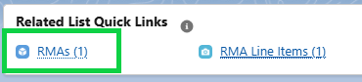

Toggle is renamed with “Bulk Update” under RMA line
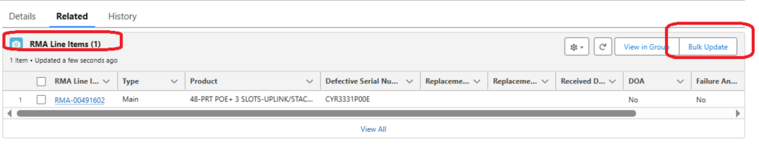
Cancel RMA
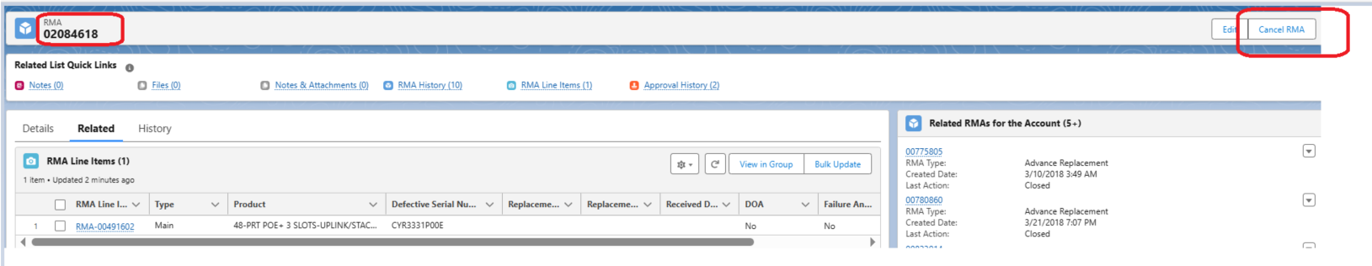

Queue Assignment
Assign the RMA sub-case to the RMA OD Queue for processing.
Error when creating RMA please contact LAT team.



